Demirci,Alpay A.

Beamer shop

Ideation document

Table of contents

Introduction 2

Information about the project 3

Wireframes 4

Sitemap 7

Git repository 7

# Introduction

This document will contain information about the ideation of a project called “Beamer Shop”.

Information such as an summary of what the project is about and the purpose of the project. This document also contains visualized information such as wireframes and a sitemap.

A git repository link of this project will be provided in this document.

# Information about the project

Beamer Shop is a project that will make buying cars as easy as buying clothes. Beamer Shop is focused on one brand: BMW. The Beamer Shop project will have an web application shop where customers that are planning to buy a car but do not want to go to car dealerships, can look for a car online, put it in a shopping cart and order the items in the shopping cart to get the car delivered at their homes. Customers can find a car even easier by using advanced filtering and searching trough the collection of Beamer Shop. Also customers can register an account so the next time they are buying a car they don’t have to fill any address or banking details.

Beamer Shop will have an desktop application for the admin panel where admins can add, view, change and delete cars/accounts. The admin panel also gives access to view and process orders.

# Wireframes

There are already example wireframes created for some important pages of the web application.

Home page

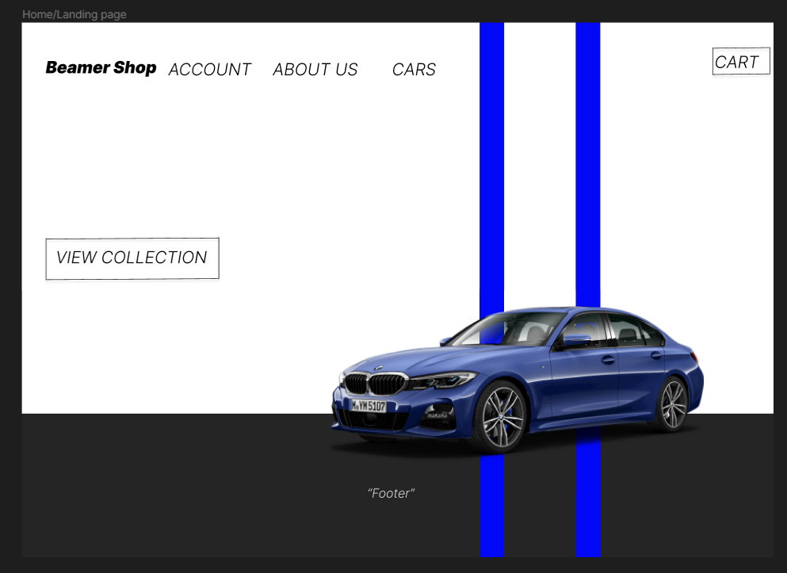

Collection page with all the cars and filtering functionality

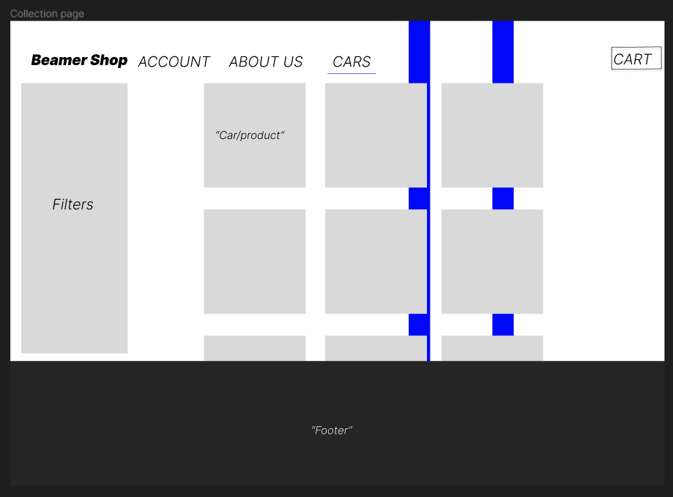

Shopping cart opened

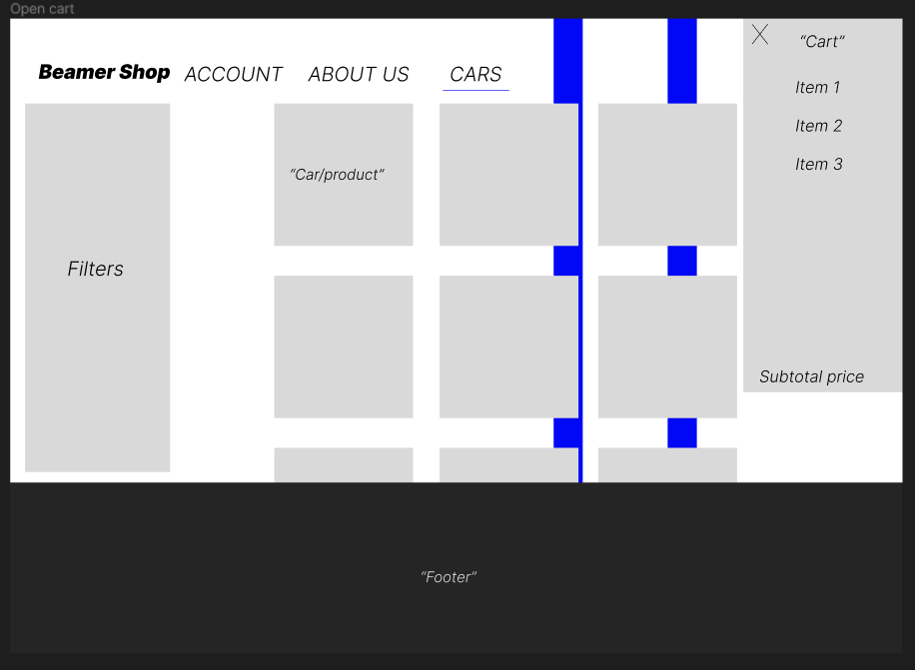

Product page of a specific car

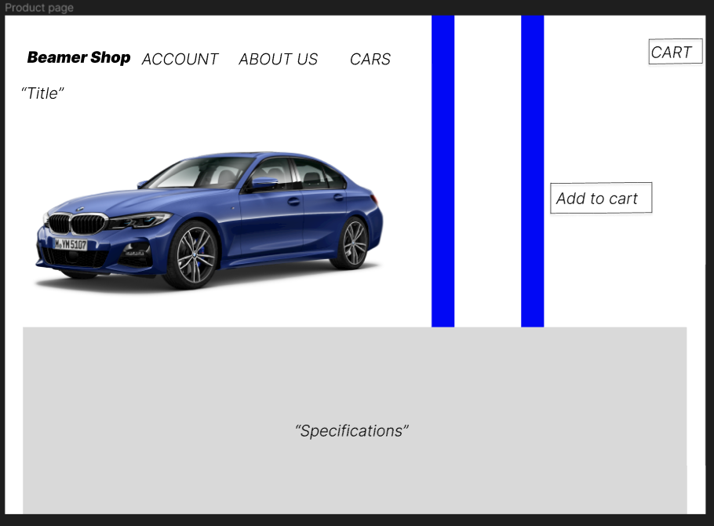

Checkout page

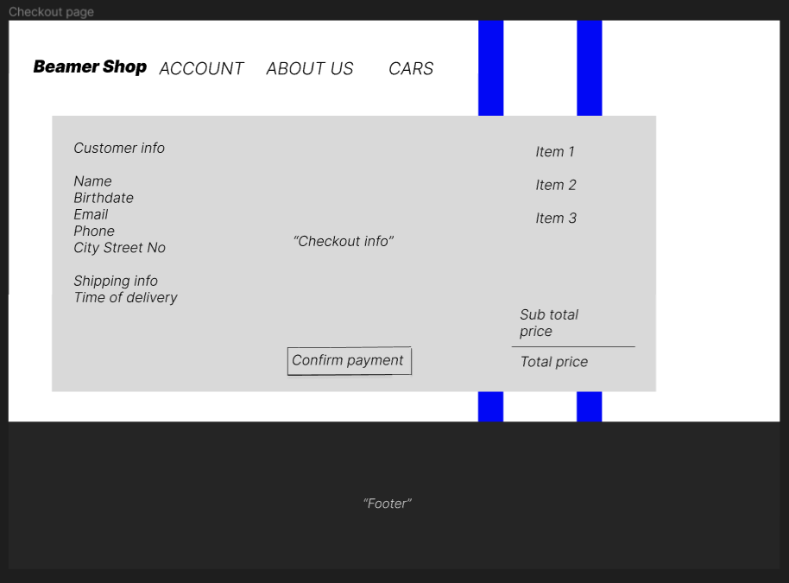

# Sitemap

Below a visual sitemap of the web application.

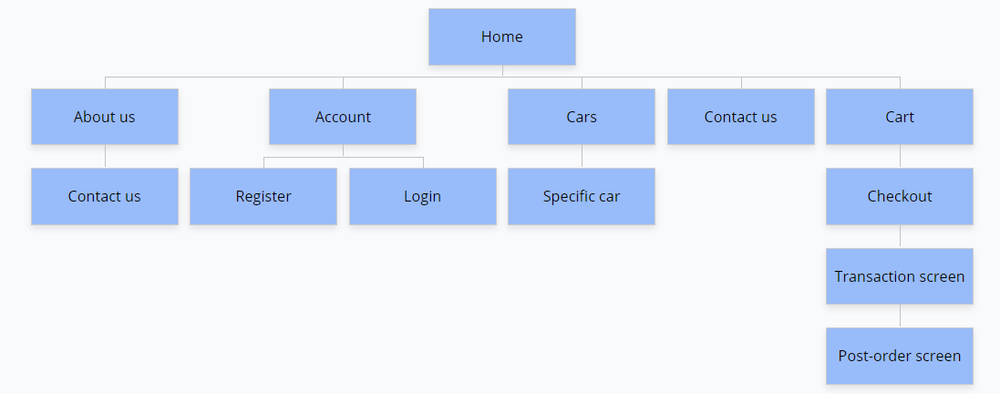

# Git repository

All the files such as documentation, diagrams, source code and database files will be in this git repository: https://git.fhict.nl/I507161/beamer_shop